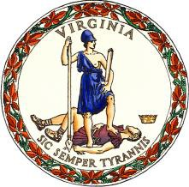

PUBLIC NOTICE

***Of***

***IN-PERSON EARLY VOTING and BALLOT DROP-BOX LOCATIONS***

***For***

***Floyd County, VIRGINIA***

**In-Person Early Voting** will be available at the following location for the June 18, 2024 Republican Primary:

for the

* Floyd County Courthouse, 100 East Main St Room 302, Floyd VA

Friday, May 3 – Saturday, June 15 from 9:00am – 5:00pm

* Also open Saturday, June 8 and Saturday, June 15 from 9:00 am - 5:00 pm
* Closed on Memorial Day, May 27, 2024

**Ballot Drop Boxes** will be available on Election Day, June 18 at each polling site in Floyd County from 6:00 am - 7:00 pm

* + Check Elementary, 6810 Floyd Hwy N, Check VA 24072
  + Floyd Elementary, 531 Oak Hill Dr SE, Floyd VA 24091
  + Floyd County High, 721 Baker St SE, Floyd VA 24091
  + Willis Elementary, 5075 Floyd Hwy S, Floyd VA 24380
  + Indian Valley Elem, 4130 Indian Valley Rd NW, Radford VA

24141

Va. Code § 24.2-701.2(E)